- Use plt.subplots() to create a 2x2 grid of subplots and plot four different types of charts (line, bar, scatter, and pie) using any sample data of your choice.
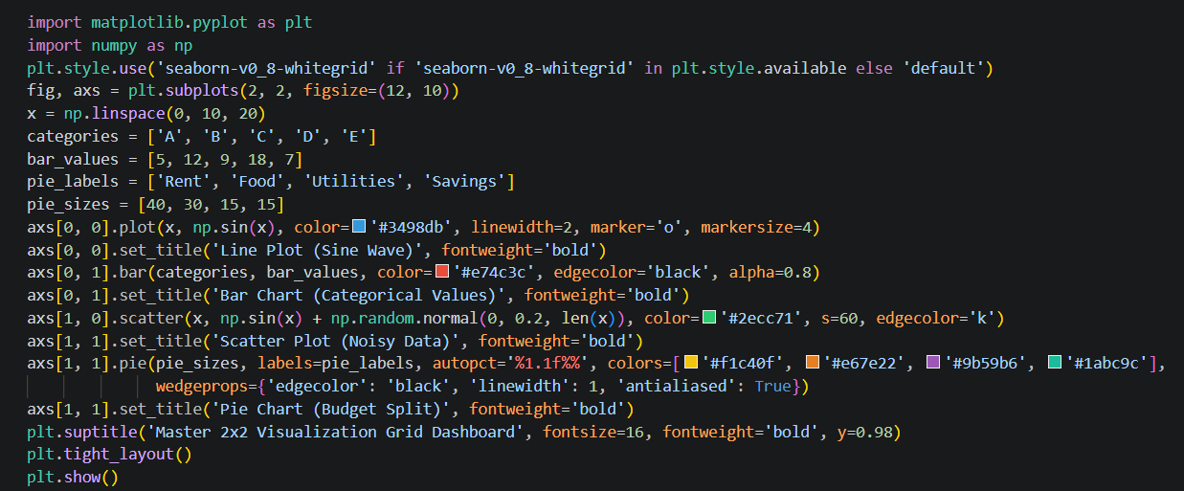
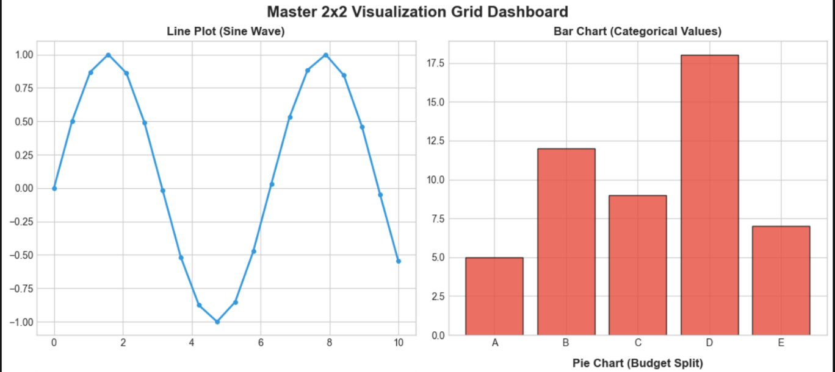
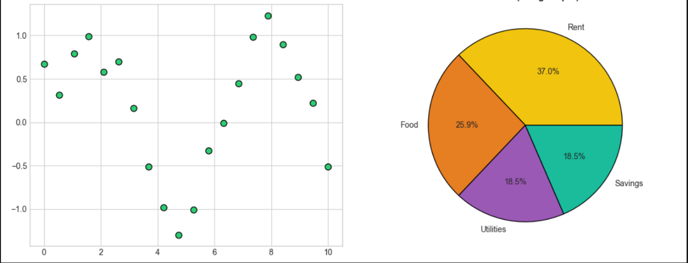

- Plot a comparison of average delivery times for Zomato, Swiggy, and Domino's using a bar chart, and style each bar with a different color, linestyle, and linewidth using Matplotlib plot styling options.
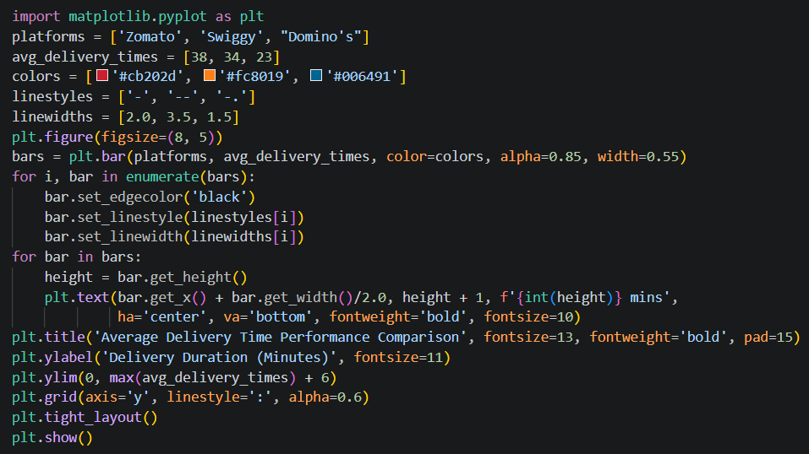
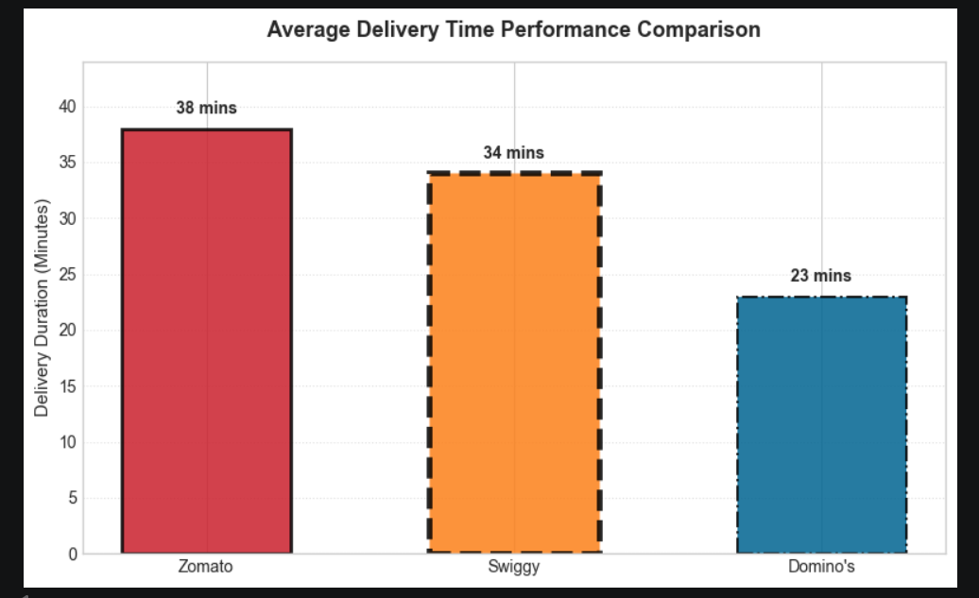

- Create a multi-axis chart that shows the number of Instagram followers (left y-axis) and average daily posts (right y-axis) for five influencers. Use different colors and markers for each axis.

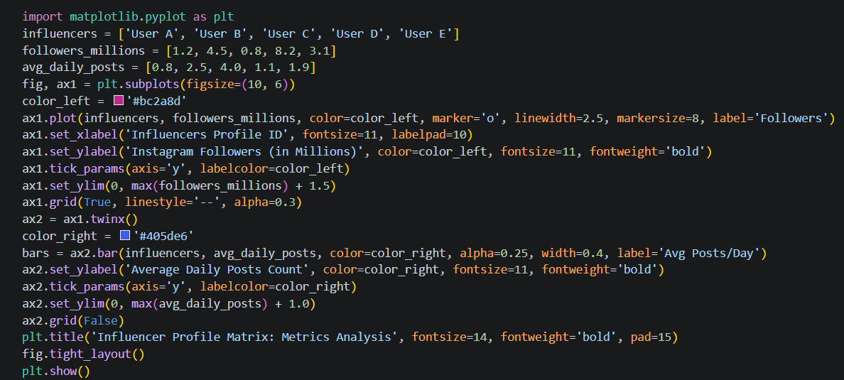
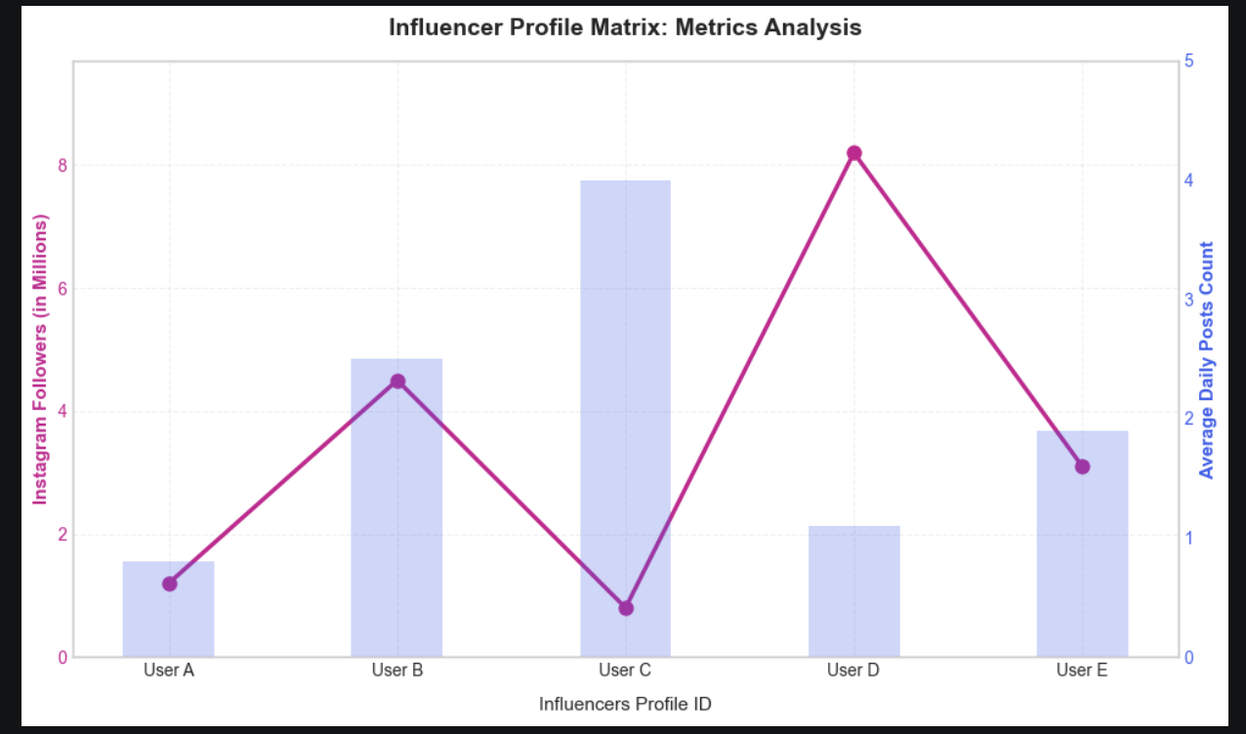

- Plot the number of tickets sold for five recent Bollywood movies (categorical) versus their IMDB ratings (numeric) using a scatter plot. Add annotations to display the movie names above each point.
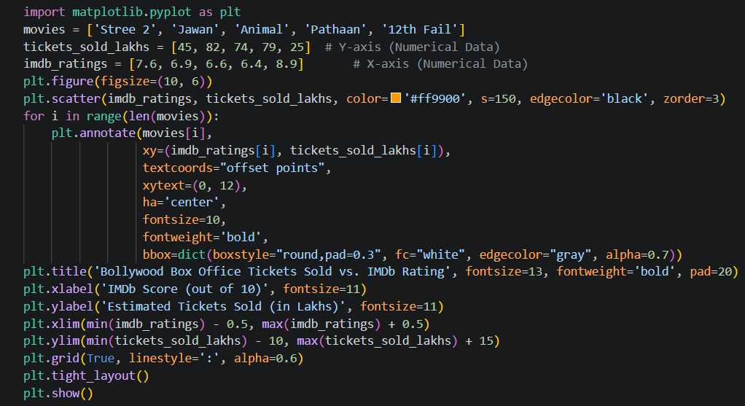
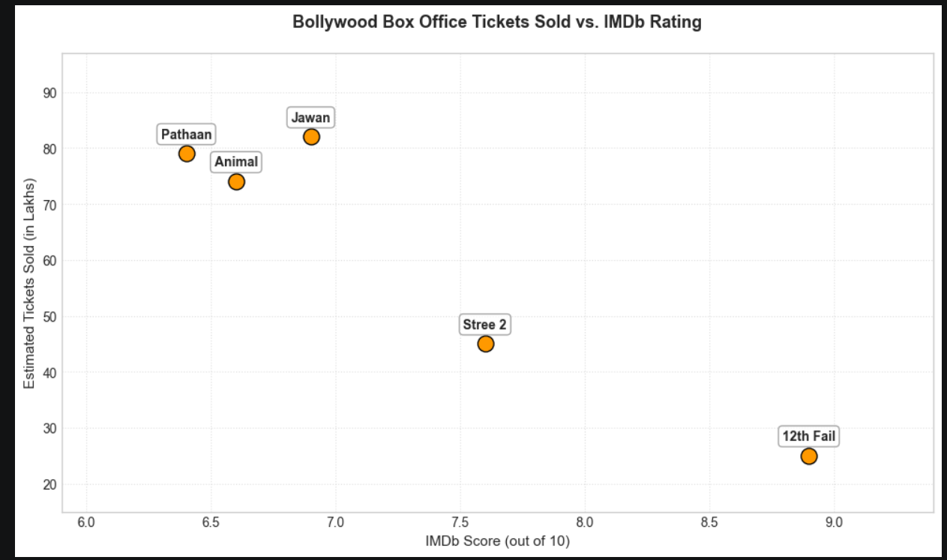

- Add a custom text annotation to a Matplotlib chart showing Flipkart's monthly sales, marking the highest sales point with the label 'Big Billion Days'. Use the ax.annotate() function to place the label at the correct data point.
